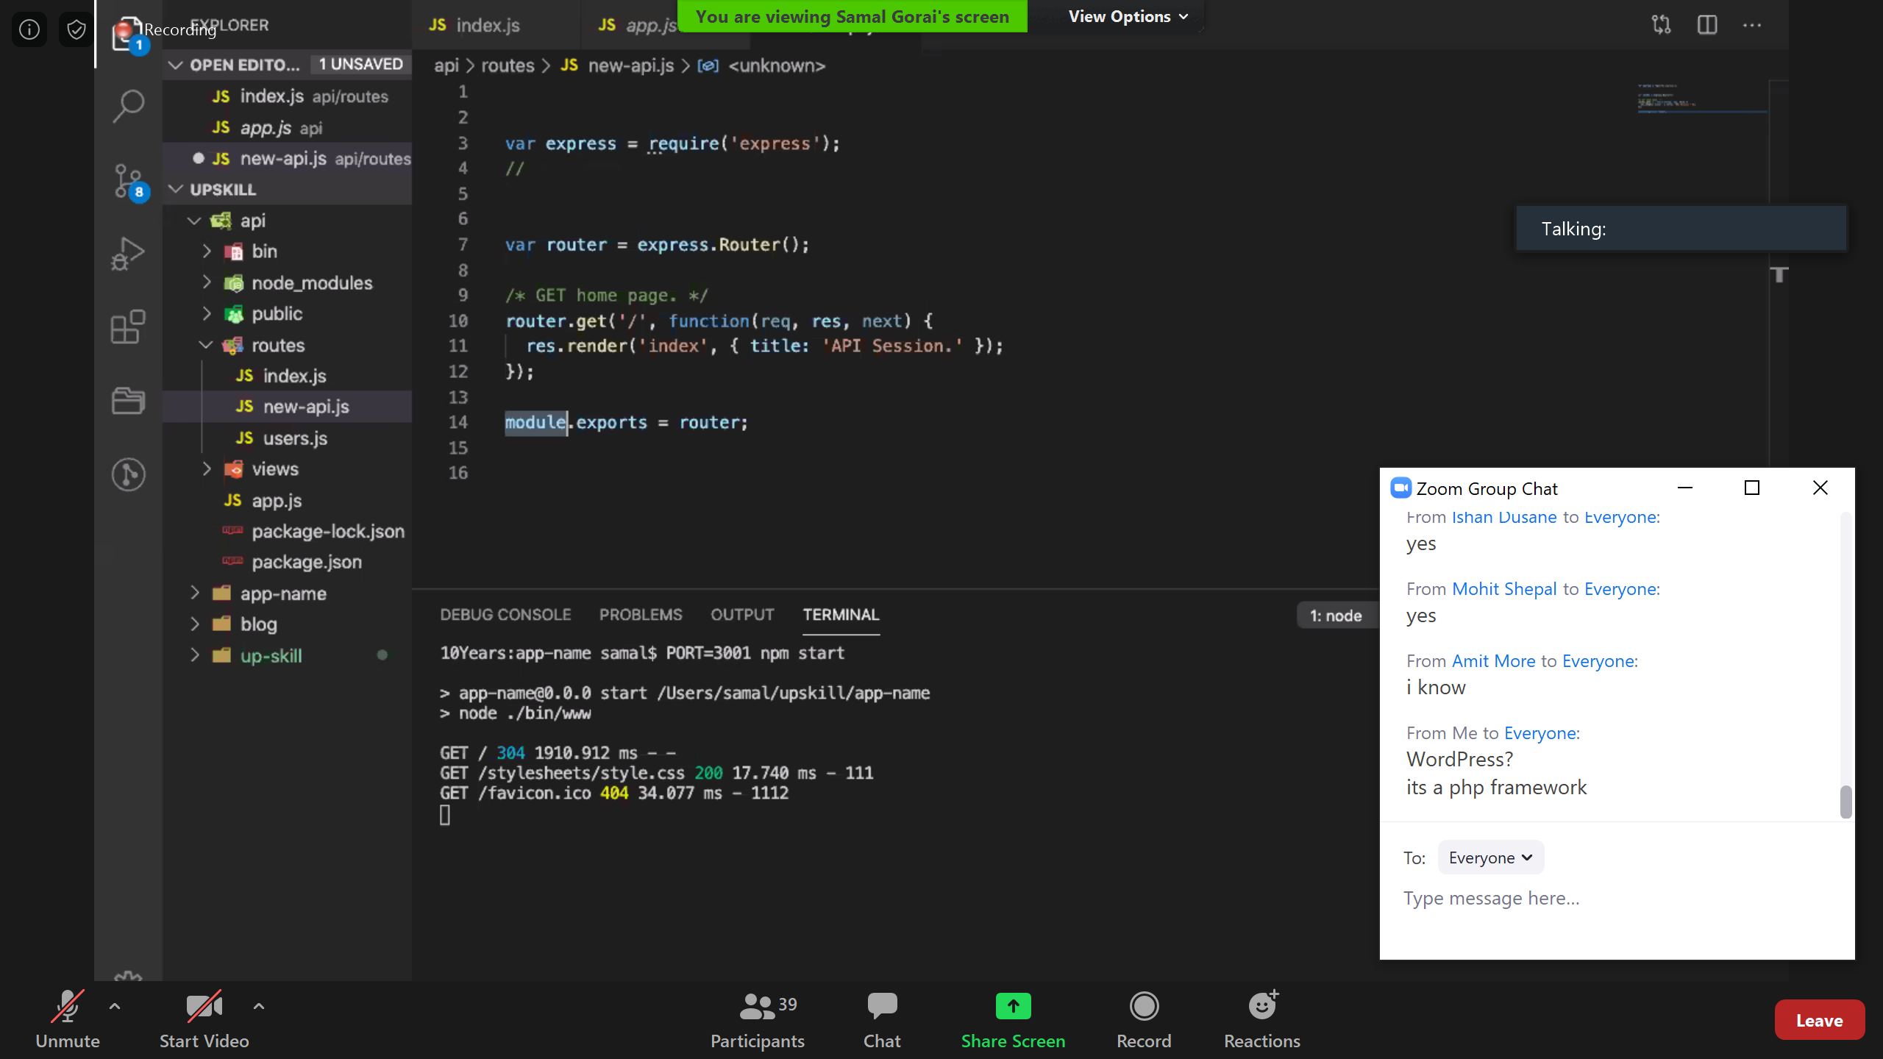

Object is an object which has a key called keys which is a method which takes one param

Keys is method return an objwhich has a key foreach again this is a method which take one param which is a function (inline function) that inline function take a single param.

Inline function expression checking values using ternary operator and assign the result into values

Object {

Keys: function(o)

{ return{

foreach: function(k)

}

}

}

Object{

Keys:function(a,b)

{ foreach:function()

{

Return function(c){